Tech Notes

QPM Torque Rate Control

Sept. ‘04 DRB

Torque Rate Control:

Monitoring the rate of change of Torque vs. Angle provides a new dimension in the control of the fastening process. With Torque Rate Control an increase in this rate to a specified level can indicate an event in the fastening process, such as the seating of a fastener, which can be used as a starting point for another fastening step, such as backing out a certain amount. Monitoring this Torque Rate can also allow us to determine the yield point of each fastener during the fastening process.

Fastener Yield Control:

The process of tightening a fastener involves stretching, or preloading, the bolt to allow it to store enough force to hold the assembled parts together. Preloading the bolt to a higher load will hold the assembled parts together with more clamp force. Preloading a fastener to the yield point of the bolt material will provide the maximum clamp force possible from each fastener. Preloading a fastener to its yield point can also assure a static loading condition for the fastener when the service loads may exceed the preload available with other fastening methods, thereby reducing the risk of fatigue failures.

A bolt acts like an extension spring. Within its elastic region, any increase in deflection will produce a proportional increase in load. But once the bolt is stretched beyond its elastic limit and into the plastic region, the same incremental amount of deflection will produce a proportionally smaller increase in load. As long as the bolt is preloaded within its elastic limit, no permanent deformation of the bolt will occur. When unloaded, it will return to its original length. But once the bolt is deflected beyond its elastic limit and into the plastic region, permanent elongation will occur. The yield point of a material is traditionally defined as the point at which 0.2% permanent elongation occurs.

When tightening a fastener, the applied Torque is directly proportional to Load, and the Angle of rotation is directly related to the Deflection through the thread pitch. By monitoring the dynamic Torque and the Angle of rotation during a fastening cycle (beyond the initial free run-down and pull-up phases of a fastening cycle), the rate of change of Torque vs. Angle is directly related to the rate of change of Load vs. Deflection of the bolt material, thereby providing a convenient method for monitoring the onset of the elastic limit of the bolt material. The QPM controller software can now detect this fastener yield point and stop the fastening process when this occurs.

Fastener Yield Control with the Stanley QPM Controllers:

QPM software Version “3.0.0.0” contains the fastening algorithms that allow the QPM fastening system to perform the Fastener Yield Control strategy.

This fastening strategy calculates and monitors the Torque vs. Angle Rate, starting at the Snug Torque, and this Torque Rate is used as the control variable. When calculating the Rate, a user-selectable parameter allows the torque to be averaged over a number of torque sample points (P165). Another user-selectable parameter allows the rate to be calculated over a pre-selected angle window (P159). Using these parameters, the Torque Rate is continuously calculated every millisecond during the fastening cycle and the peak Rate value is stored in memory. The tool is shut off when the Rate reaches the pre-selected Yield Target defined as a portion of the peak Rate value. Alternately, the tool will shut off if the High Torque limit (P007), or the High Angle Limit (P013) is reached prior to sensing a Yield condition, and the red High Torque or High Angle light will be actuated.

Yield Control Summary QPM_9-04.doc | 1

Tech Notes

QPM Torque Rate Control

Please note that this Fastener Yield Control strategy can be combined with other control strategies in a multiple-step fastening cycle. If the process specifications require a certain amount of permanent bolt elongation, then an additional Angle Control step can be applied after Yield has been detected to control the amount of bolt elongation.

Control Parameters for Fastener Yield Control:

In order to enable Fastener Yield Control for a fastening step, you must set P000 (Strategy) to 6 (Yield) for that step. The parameters needed for Yield Control are as follows:

Param. | Name | Description
No.
000 | Yield Strategy | Strategy selection. Setting P000 to 6 will enable Yield
 |  | Control.
161 | Yield Target | Control point for Yield Control. Rate must drop to this
 |  | portion of its peak value to end cycle. Acceptable
 |  | values 0 - 0.9. A lower value allows more fastener
 |  | yield.
165 | Smoothing Factor | Number of Torque samples averaged for the Rate
 |  | calculation. Torque samples are taken every
 |  | millisecond, and a running average is calculated based
 |  | on this factor. Higher number gives a smoother Rate.
159 | Rate Calc Interval | Angle interval used to calculate the Torque vs. Angle
 |  | Rate. Larger interval tends to give a smoother Rate.
015 | Snug Torque | Torque at which the controller will begin to calculate the
 |  | Rate. Set this to begin at the linear portion of the
 |  | Torque vs. Angle rate.
007 | High Torque | Alternative control point. Cycle will end at this Torque if
 |  | Yield has not been sensed, and the High Torque red
 |  | light will be activated.
013 | High Angle | Alternative control point. Cycle will end at this Angle
 |  | (beyond Snug Torque) if Yield has not been sensed,
 |  | and the High Angle red light will be activated.

The Yield Target is given as a portion of the peak rate (0 to .9). If the user selects a value of 0.5, shut-off will occur when the Torque vs. Angle Rate drops to 50% of the peak Rate value for that cycle. If the user selects a value of zero, shut-off will occur when the Torque vs. Angle Rate drops to zero, indicating no increase in Torque during the previously selected Rate Calculation Interval.

The Smoothing Factor provides a simple method of smoothing the Rate trace when the Torque signal is rough. This method allows the trend of the Rate to be viewed without the momentary aberrations resulting from the normal variations in the torque signal, and is used to prevent a

Yield Control Summary QPM_9-04.doc | 2

Tech Notes

QPM Torque Rate Control

false indication of fastener yield. Selecting a larger Rate Calculation Interval will also help smooth the Rate.

Following the cycle, the Peak Torque and Peak Angle for that cycle are displayed on the controller and recorded in the cycle log.

Torque Rate Control with the Stanley QPM Controllers:

QPM software Version “3.0.0.0” contains the fastening algorithms that also allow the QPM fastening system to perform the TRC strategy. As with the Yield Control strategy, this TRC can be combined with other fastening steps in a multi-step fastening cycle.

Control Parameters for TRC Control:

In order to enable Torque Rate Control for a fastening step, you must set P000 (Strategy) to 5 (TRC) for that step. The parameters needed for Torque Rate Control are as follows:

Param. | Name | Description
No.
000 | TRC Strategy | Strategy selection. Setting P000 to 5 will enable
 |  | Torque Rate Control.
169 | Torque Rate Target | Control point for TRC. Rate must be equal to or
 |  | greater than this value to end the cycle. Units are
 |  | Nm/Deg.
165 | Smoothing Factor | Number of Torque samples averaged for the Rate
 |  | calculation. Torque samples are taken every
 |  | millisecond, and a running average is calculated based
 |  | on this factor. Higher number gives a smoother Rate.
159 | Rate Calc Interval | Angle interval used to calculate the Torque vs. Angle
 |  | Rate. Larger interval tends to give a smoother Rate.
015 | Snug Torque | Torque at which the controller will begin to calculate the
 |  | Rate. Set this to begin at the linear portion of the
 |  | Torque vs. Angle rate.
007 | High Torque | Alternative control point. Cycle will end at this Torque if
 |  | Yield has not been sensed, and the High Torque red
 |  | light will be activated.
013 | High Angle | Alternative control point. Cycle will end at this Angle
 |  | (beyond Snug Torque) if Yield has not been sensed,
 |  | and the High Angle red light will be activated.

With either of these strategies, the Peak Torque and Peak Angle for that cycle are displayed on the controller and recorded in the cycle log.

Yield Control Summary QPM_9-04.doc | 3

Tech Notes

QPM Torque Rate Control

Graphical depiction of control parameters:

Torque

Rate Parameters
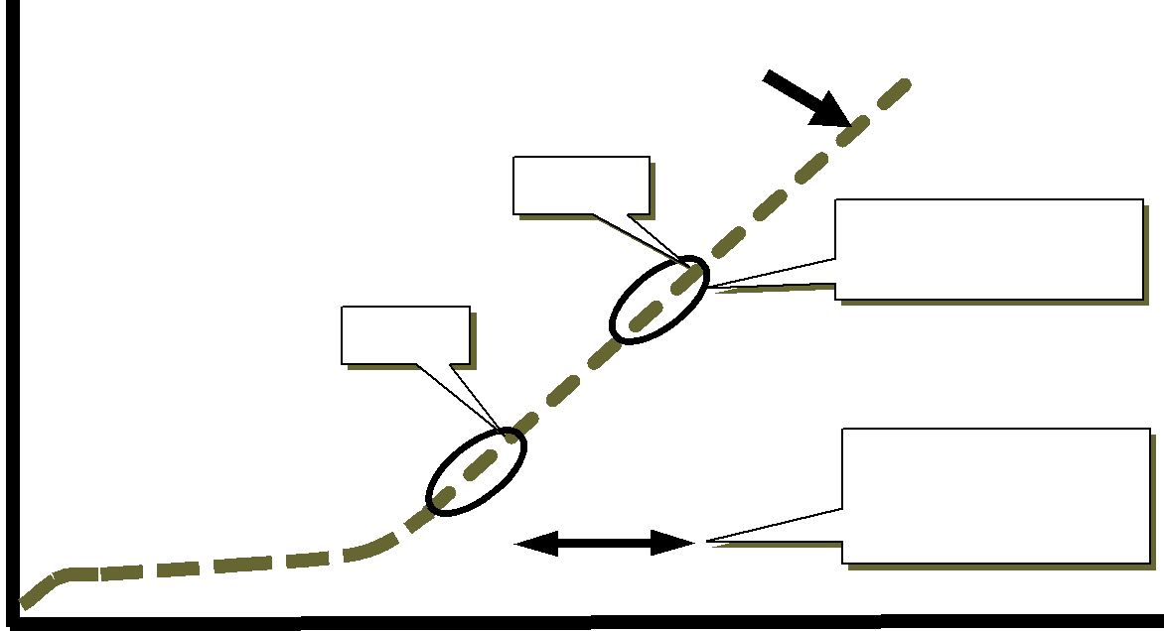

 |  |  |  | Torque
 |  |  |  | T2, A2
Rate = T / A |  |  |  |  |  |  | P165
 |  |  |  |  |  |  | Smoothing Factor
 |  | T1, A1 |  |  |  | ΔT
 |  |  |  |  |  |  | P159
 |  |  |  | ΔA
 |  |  |  |  |  |  | Rate Calculation
 |  |  |  |  |  |  | Interval
 |  | 1 ms Samples |  |  |  |  | Angle

Yield Control Summary QPM_9-04.doc | 4

Torque (Nm)

Tech Notes
QPM Torque Rate Control

Yield Control Parameters

P007 High Torque |  |  |  |  |  | P013HighAngle |  | Rate(Nm/Deg)
 |  |  | Yield
Torque
 |  |  |  | Peak Rate
Rate |  |  | ΔT
 | ΔA
P015 Snug Torque |  |  |  |  |  |  | P161
 | Control |  |  |  |  | Yield Target
 |  |  |  |  |  | % of Peak Rate
 |  | Point
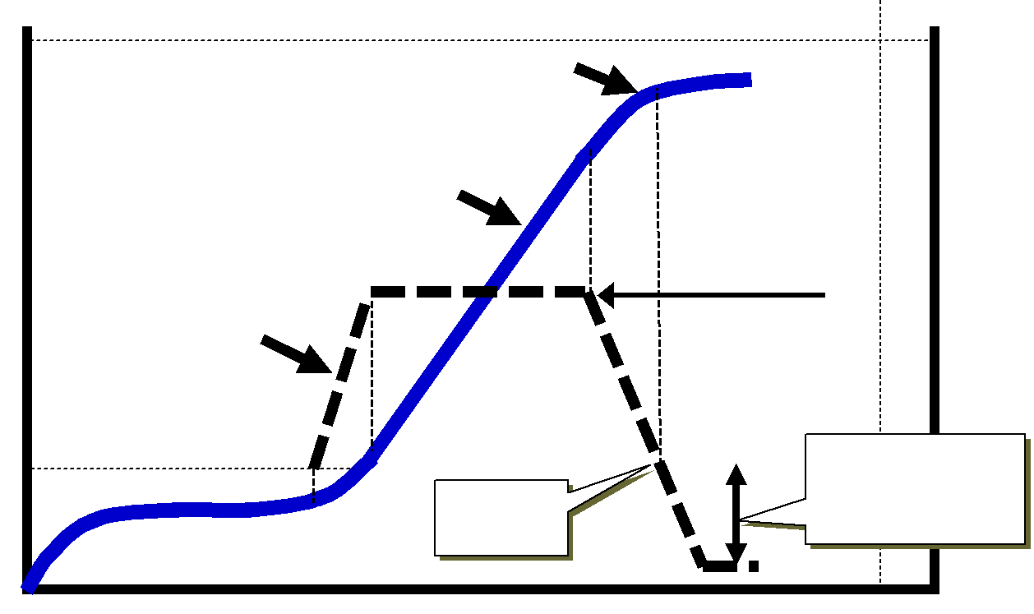

Angle (Deg)

Yield Control Summary QPM_9-04.doc | 5

Torque (Nm)

Tech Notes
QPM Torque Rate Control

Torque Rate Control Parameters
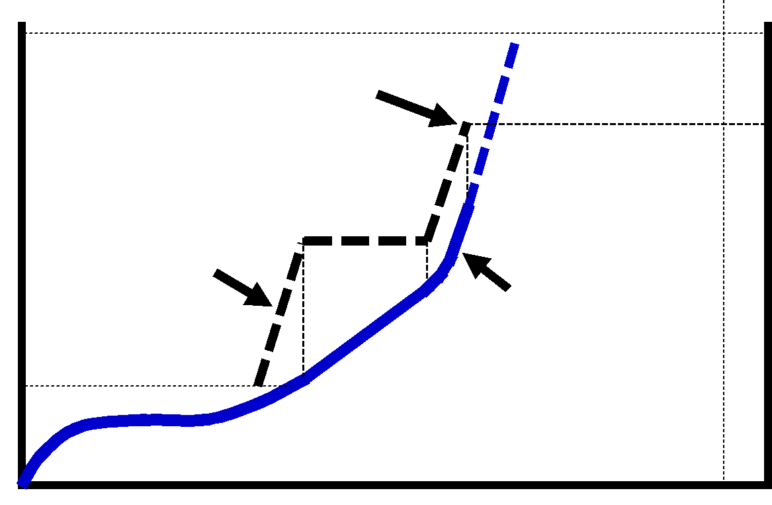

P007 High Torque

 | Control
 | Point |  | P169 Rate Target |  | (Nm/Deg)
Rate |  |  |  | Angle
 |  |  |  | P013High | Rate
 |  |  | Torque
P015 Snug Torque |  |  | ΔTorque
 | ^{ΔAngle}Rate = T / A

Angle (Deg)

Yield Control Summary QPM_9-04.doc | 6

Tech Notes

QPM Torque Rate Control

Limitations & Recommendations for Yield Control:

The type of fasteners used and the make-up of the assembled components can have a significant effect on the success of implementing a Fastener Yield Control strategy. If the fastened components can yield throughout the assembly process, this can be interpreted as fastener yield. Since the cross-sectional area of the threaded portion of a bolt is less than the area of the shank portion, all the yield will occur in the threaded area. Bolts with reduced areas in the shank portion will distribute the yield over a greater length. The Yield Control Strategy tends to work better on joints with longer bolt grip lengths which allow greater total bolt elongation.

Since the angle of rotation is a key element in this strategy, we don’t recommend this fastening strategy be used with hand-held assembly tools. We understand that the nature of some applications will require a back-up wrench to be hand-held on the opposite end of the assembly. Our limited tests showed no adverse effect when hand-holding the back-up wrench.

Since this fastening strategy will tighten any fastener to its yield point, a different grade fastener will yield at a different Load value. We recommend caution to assure that other grade fasteners are not mixed with the fasteners intended for this application. The consistency of fastener material properties within a given Grade is also critical for good Clamp Load control.

This fastening strategy is not a substitute for good fastener quality control. Slight variations in frictional properties of fastener components will not affect the Clamp Load control. But certain applications will exhibit the occasional “stick-slip” condition which can affect the ability to sense the onset of fastener yield.

A fastener yield strategy can be difficult to verify in a production environment. During laboratory tests, we can measure each fastener before and after each assembly to verify that yield had occurred. Disassembling product parts is not practical, but we recommend an off-line test fixture to allow the production tooling to be run on production fasteners and fastener elongation measured on a statistical sampling basis. We also recommend that occasionally observing the Torque vs. Angle trace in production can provide a quick indication that fastener Yield is indeed occurring.

Any embedment or joint relaxation which occurs after the fastening process can affect the final clamp load. We recommend a complete laboratory analysis of the joint to understand any characteristics that may affect the final clamp load before implementing this fastening strategy.

Yield Control Summary QPM_9-04.doc | 7

